**To access RDS of cloud from local laptop**

**Step-1**

**You must have mySQL client(either command line or workbench) on your local Laptop**

**You need**

**1.i/p address**

**2.userbane**

**3.password**

**4.db name**

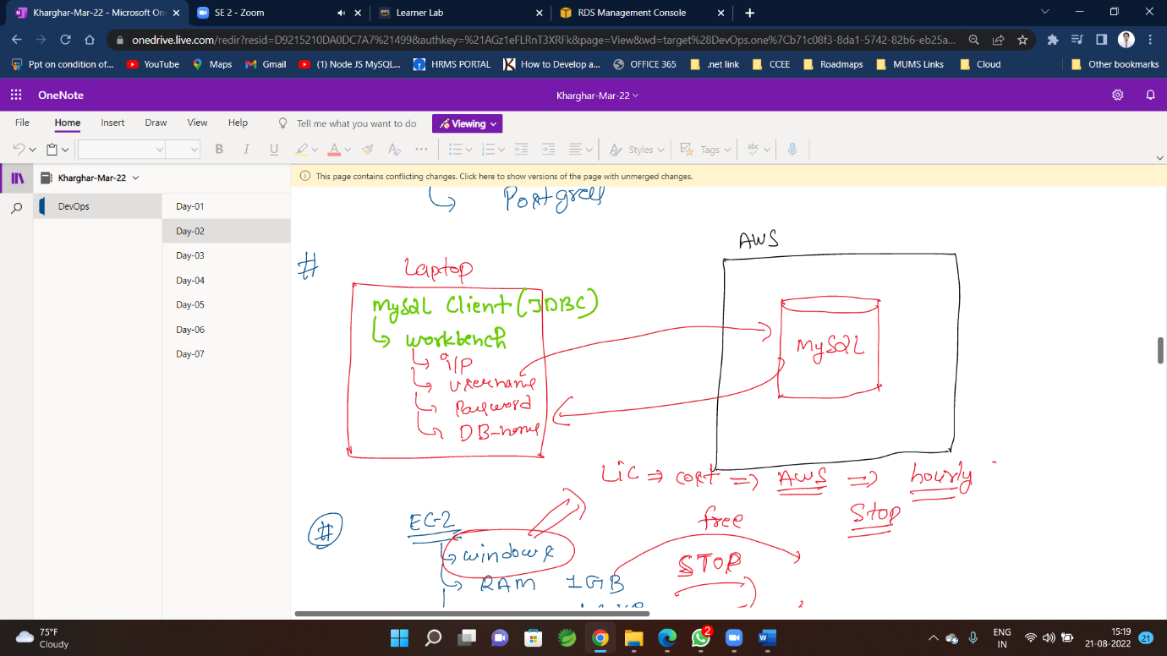

**Step-2**

**Click on database name to get credentials**

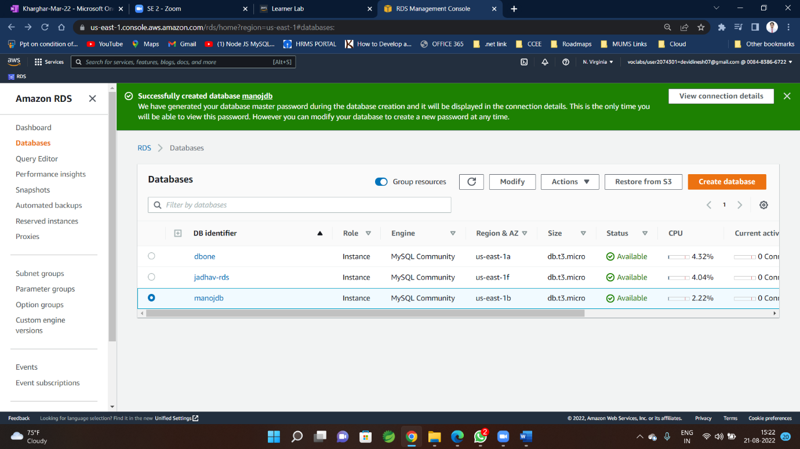

**Step-3 copy Endpoint this will be the ip and port details given**

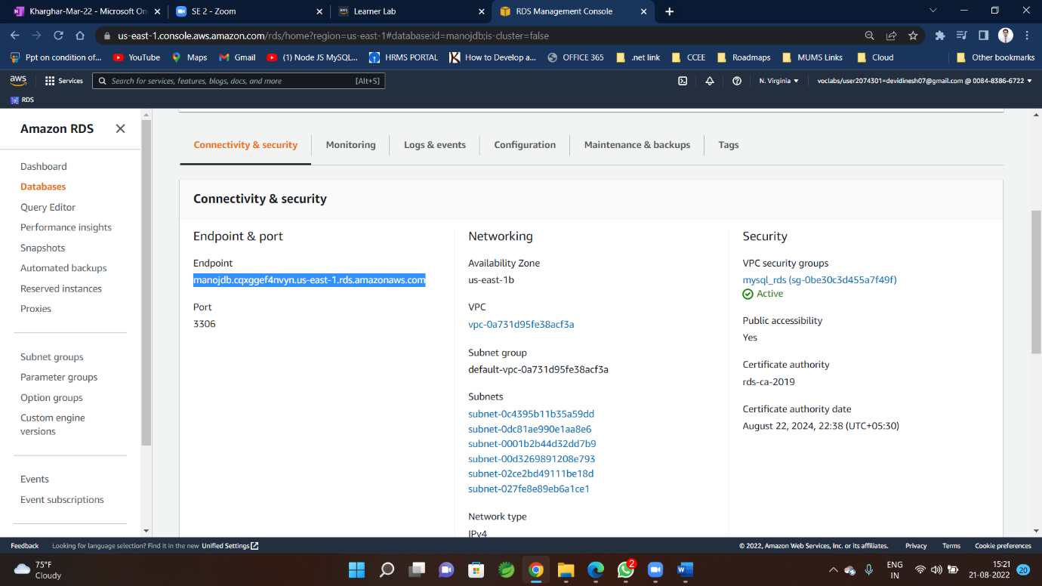

**Step-4**

**open MySQL Workbench in your Laptop and click on +**

**for new connection**

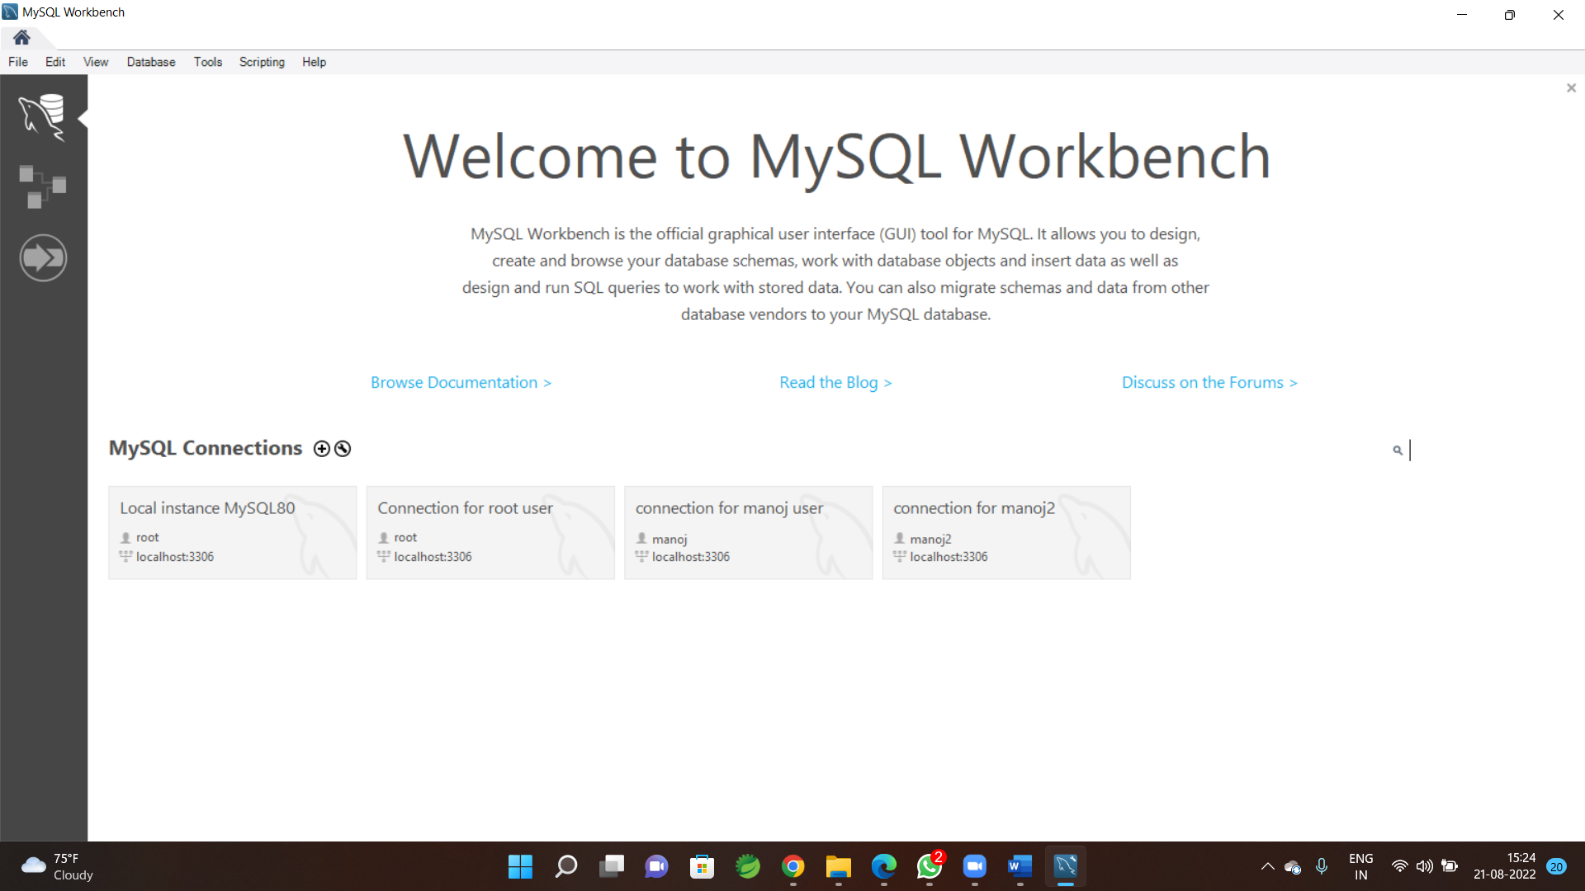

**Step-5**

**Paste Endpoint (from RDS details) in hostname keep port same**

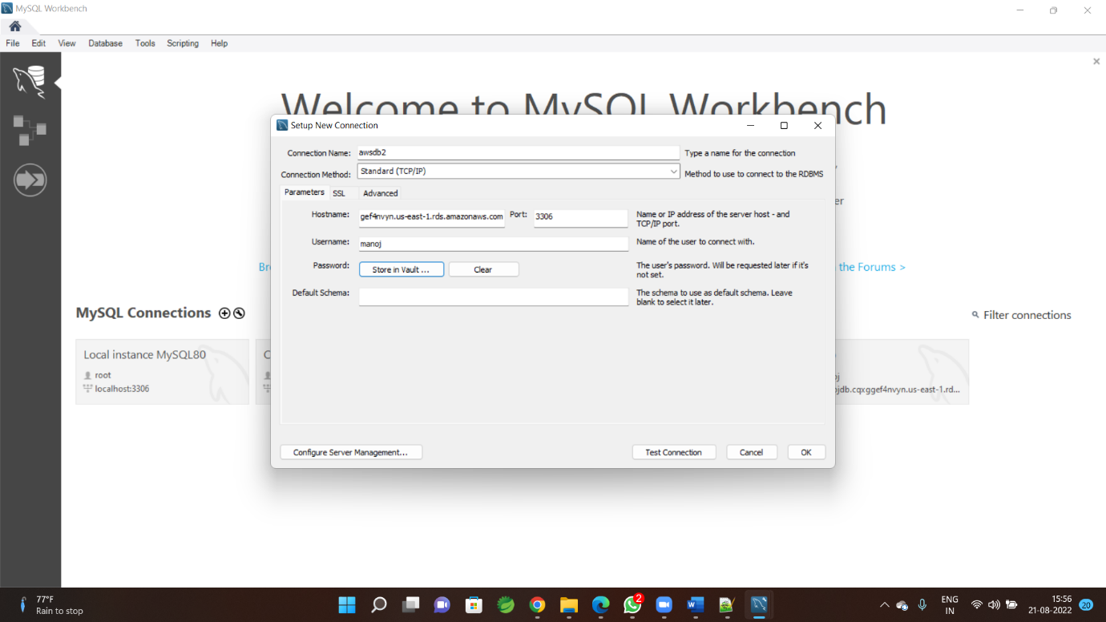

**Give User name same as you given while creating RDS**

**Step-6**

**copy Password from here**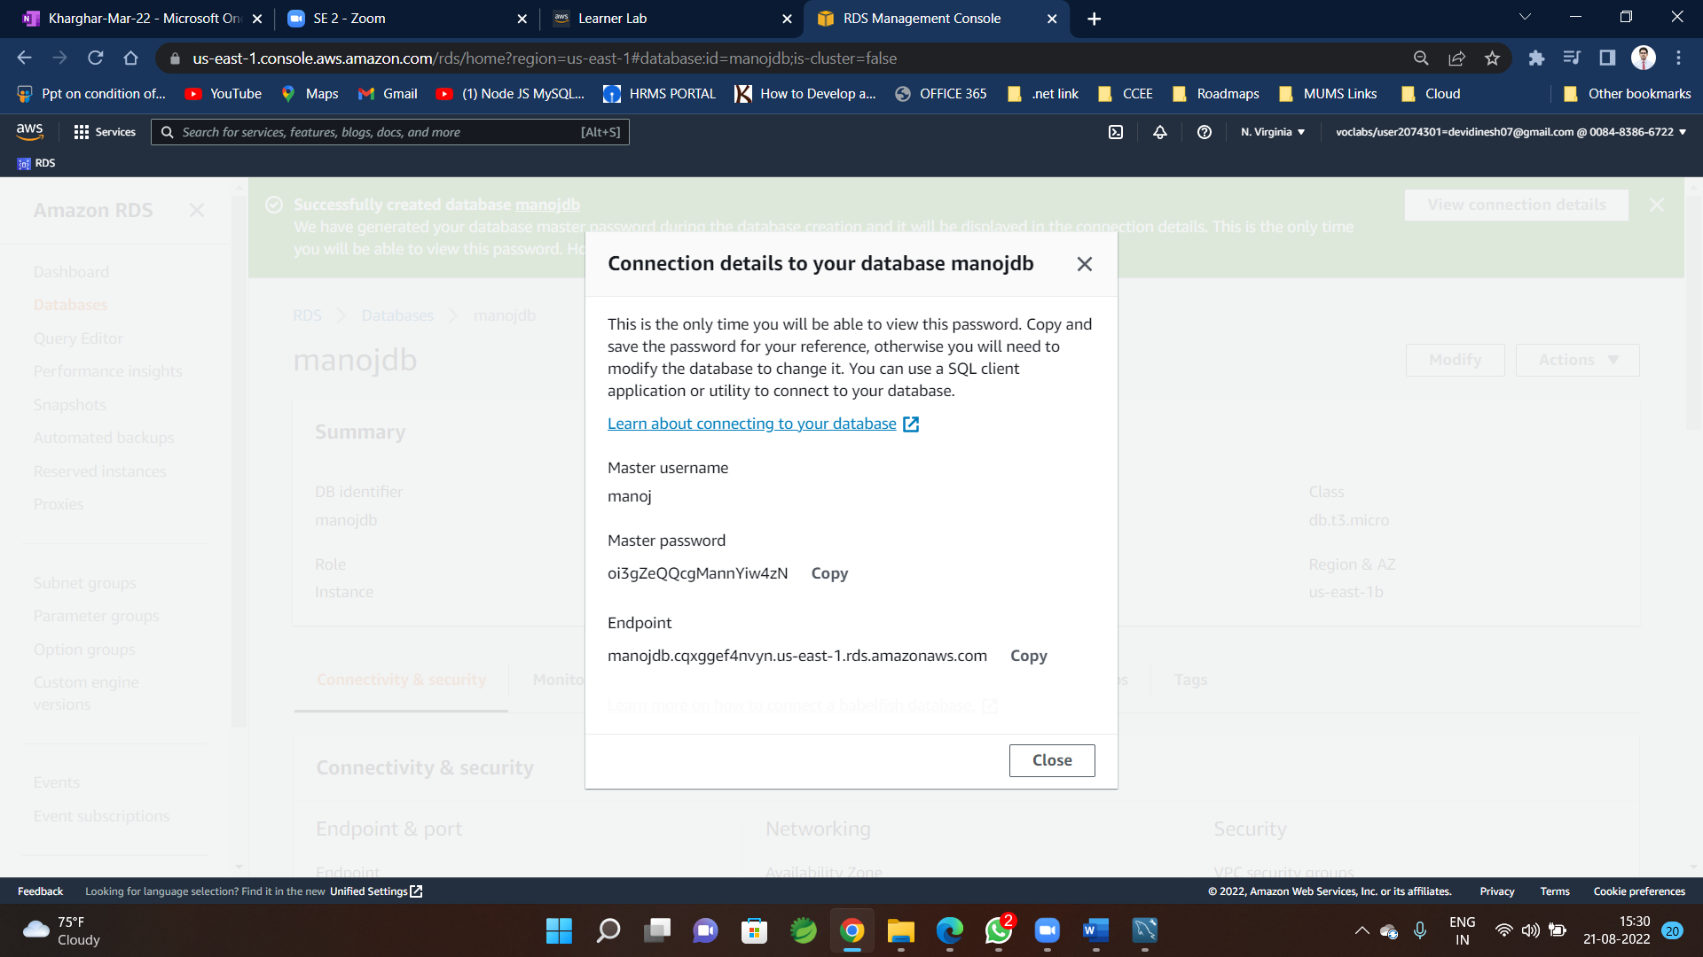

**and paste in MySQL To here**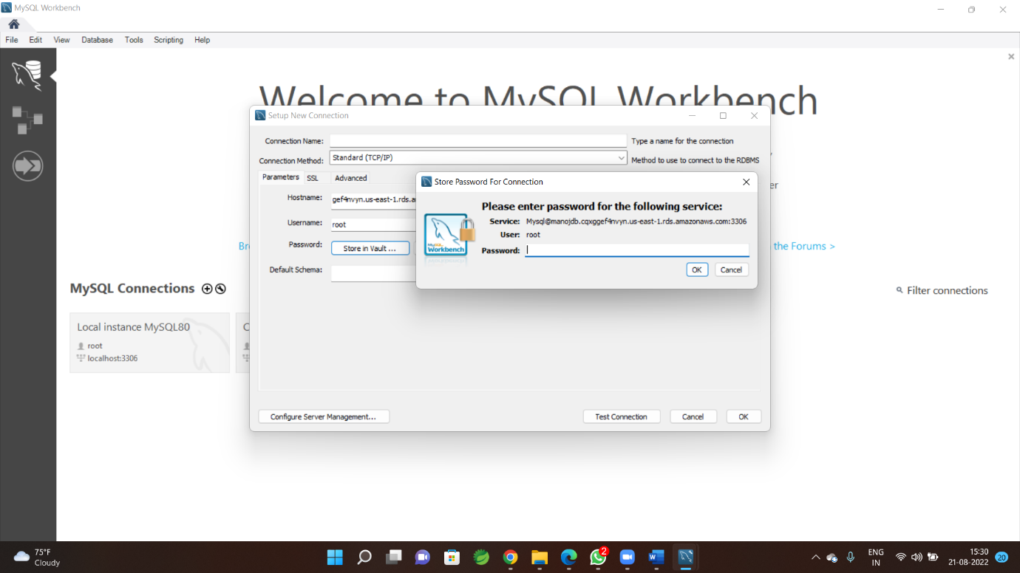

**Step-7**

**Enter connection name (any of your choice)**

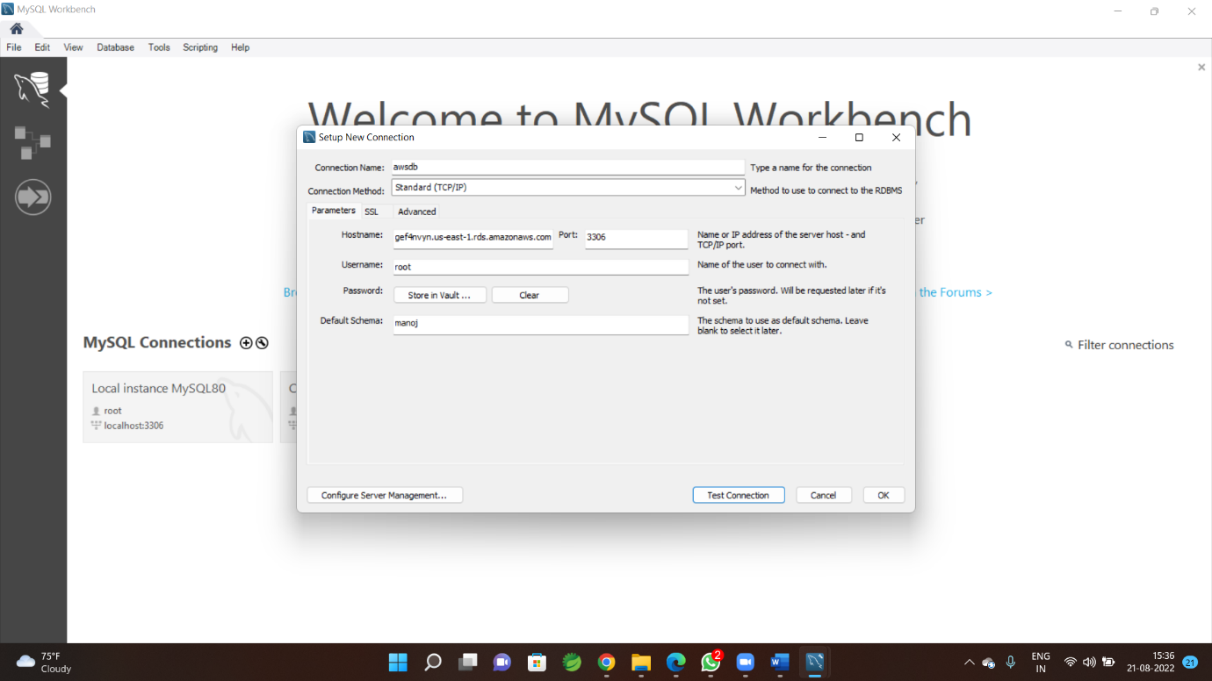

**Now click on Test Connection**

**Step-8**

**If test fails check security group**

**Right click and open in new tab**

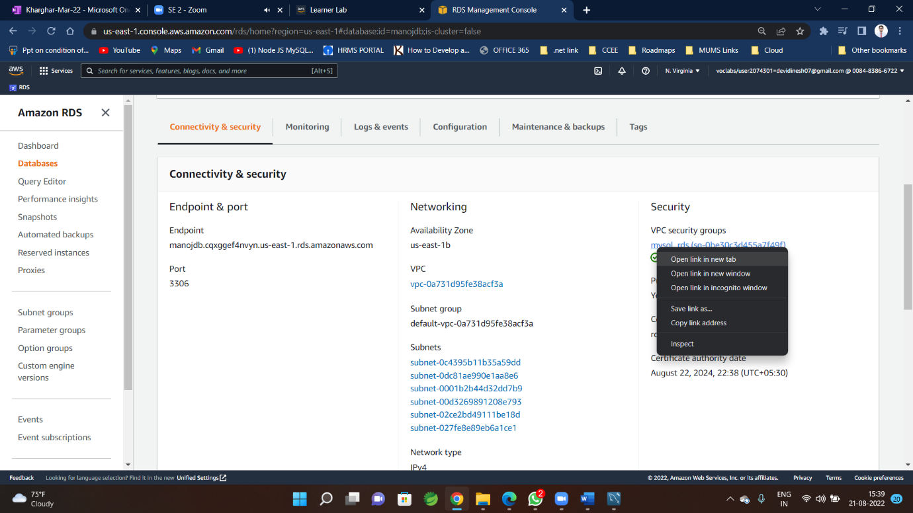

**Step-9**

**In new window of security group of RDS**

**securitygroup🡪 Click on 🡪inbound Rules🡪Edit Inbound rule** 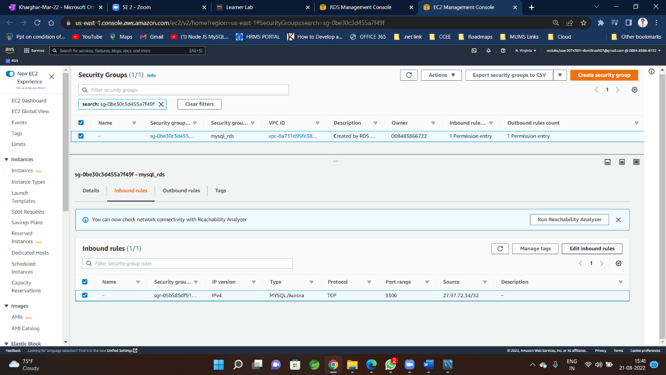

**Step-10**

**Make it Public**

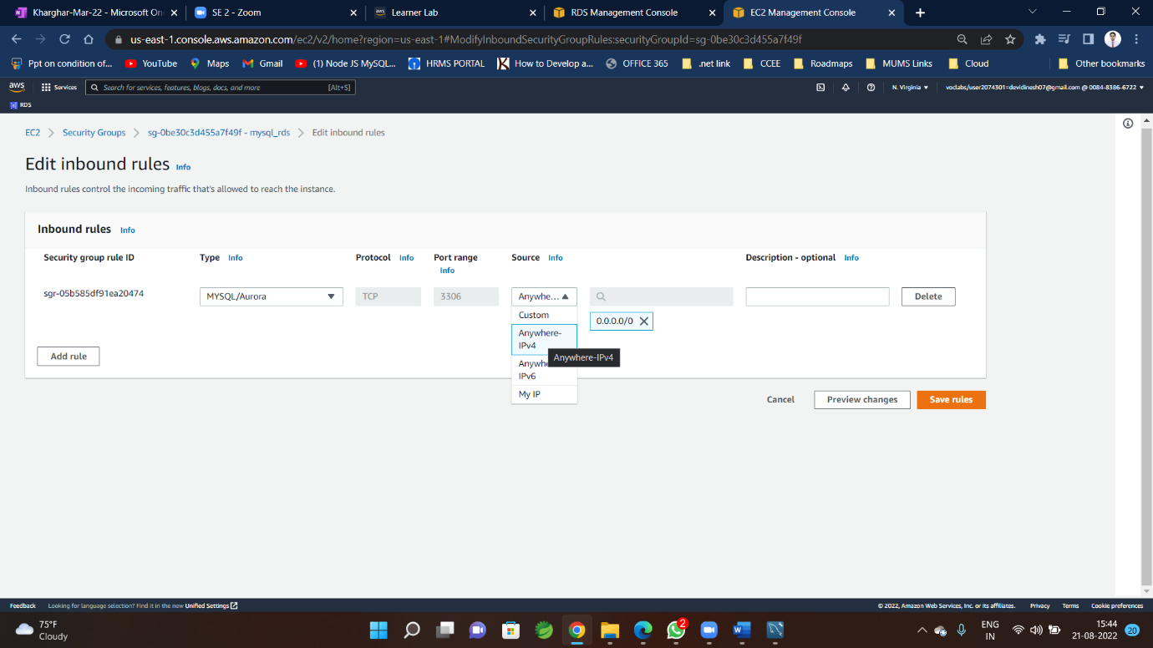

**Step-11**

**Successful connection**

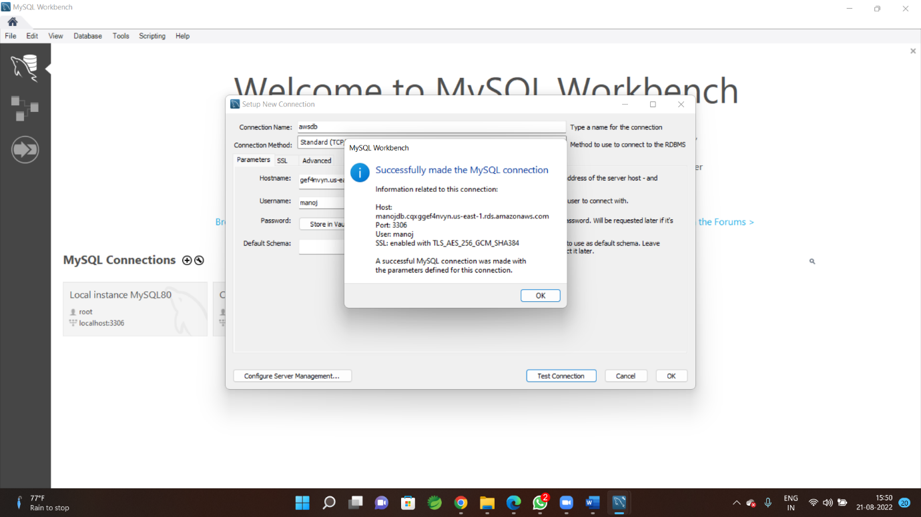

**Step-12**

**Create and use**

